Notes for MCA-I (Semester- I)
Subject :- Object Oriented Software Engineering
(Subject Code:- IT-13)
Chapter: 1] Introduction to development approach SSAD
and OOAD

- Software Engineering: - The term software engineering is the product of two words, software, and engineering.
The software is a collection of integrated programs.
Software subsists of carefully-organized instructions and code written by developers on any of various particular computer languages.
Computer programs and related documentation such as requirements, design models and user manuals.
Software engineering is an engineering branch associated with development of software product using well-defined scientific principles, methods and procedures. The outcome of software engineering is an efficient and reliable software product.
Software is more than just a program code. A program is an executable code, which serves some computational purpose. Software is considered to be collection of executable programming code, associated libraries and documentations. Software, when made for a specific requirement is called software product.
Engineering on the other hand, is all about developing products, using well-defined, scientific principles and methods.
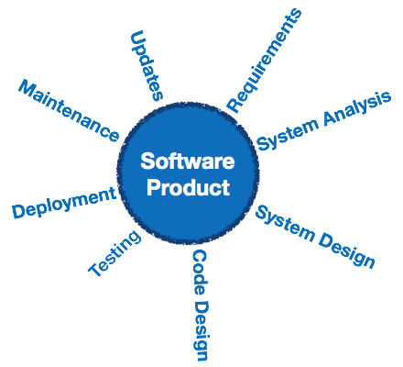
Software engineering is an engineering branch associated with development of software product using well-defined scientific principles, methods and procedures. The outcome of software engineering is an efficient and reliable software product.

Definitions
software engineering defines as:
(1) The application of a systematic, disciplined, quantifiable approach to the development, operation and maintenance of software; that is, the application of engineering to software.
(2) The study of approaches as in the above statement.
Fritz Bauer, a German computer scientist, defines software engineering as:
Software engineering is the establishment and use of sound engineering principles in order to obtain economically software that is reliable and work efficiently on real machines.

Why is Software Engineering required?
Software Engineering is required due to the following reasons:
- To manage Large software
- For more Scalability
- Cost Management
- To manage the dynamic nature of software
- For better quality Management

Need of Software Engineering
The necessity of software engineering appears because of a higher rate of progress in user requirements and the environment on which the program is working.
- Huge Programming: It is simpler to manufacture a wall than to a house or building, similarly, as the measure of programming become extensive engineering has to step to give it a scientific process.
- Adaptability: If the software procedure were not based on scientific and engineering ideas, it would be simpler to re-create new software than to scale an existing one.
- Cost: As the hardware industry has demonstrated its skills and huge manufacturing has let down the cost of computer and electronic hardware. But the cost of programming remains high if the proper process is not adapted.
- Dynamic Nature: The continually growing and adapting nature of programming hugely depends upon the environment in which the client works. If the quality of the software is continually changing, new upgrades need to be done in the existing one.
- Quality Management: Better procedure of software development provides a better and quality software product.

Importance of Software Engineering
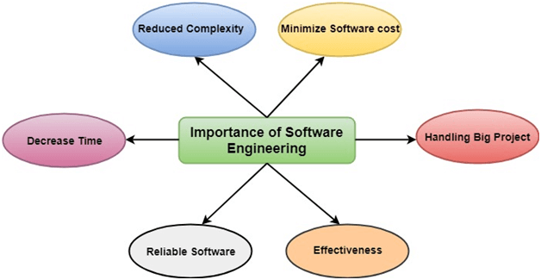
The importance of Software engineering is as follows:
- Reduces complexity: Big software is always complicated and challenging to progress. Software engineering has a great solution to reduce the complication of any project. Software engineering divides big problems into various small issues. And then start solving each small issue one by one. All these small problems are solved independently to each other.
- To minimize software cost: Software needs a lot of hardwork and software engineers are highly paid experts. A lot of manpower is required to develop software with a large number of codes. But in software engineering, programmers project everything and decrease all those things that are not needed. In turn, the cost for software productions becomes less as compared to any software that does not use software engineering method.
- To decrease time: Anything that is not made according to the project always wastes time. And if you are making great software, then you may need to run many codes to get the definitive running code. This is a very time-consuming procedure, and if it is not well handled, then this can take a lot of time. So if you are making your software according to the software engineering method, then it will decrease a lot of time.
- Handling big projects: Big projects are not done in a couple of days, and they need lots of patience, planning, and management. And to invest six and seven months of any company, it requires heaps of planning, direction, testing, and maintenance. No one can say that he has given four months of a company to the task, and the project is still in its first stage. Because the company has provided many resources to the plan and it should be completed. So to handle a big project without any problem, the company has to go for a software engineering method.
- Reliable software: Software should be secure, means if you have delivered the software, then it should work for at least its given time or subscription. And if any bugs come in the software, the company is responsible for solving all these bugs. Because in software engineering, testing and maintenance are given, so there is no worry of its reliability.
- Effectiveness: Effectiveness comes if anything has made according to the standards. Software standards are the big target of companies to make it more effective. So Software becomes more effective in the act with the help of software engineering.
- 1.1 Overview of Software Development with SSAD :- Structured Systems Analysis and Design (SSAD) Method ,The three most important techniques that are used in SSAD Method are as follows :

- Logical Data Modeling
The process of identifying, modeling and documenting the data requirements of the system being designed. The result is a data model containing entities (things about which a business needs to record information), attributes (facts about the entities) and relationships (associations between the entities).

- Data Flow Modeling
The process of identifying, modeling and documenting how data moves around an information system. Data Flow Modeling examines processes (activities that transform data from one form to another), data stores (the holding areas for data), external entities (what sends data into a system or receives data from a system), and data flows (routes by which data can flow).

- Entity Event Modeling
A two-stranded process: Entity Behavior Modeling, identifying, modeling and documenting the events that affect each entity and the sequence (or life history) in which these events occur, and Event Modeling, designing for each event the process to coordinate entity life histories.

Stages
The SSAD method involves the application of a sequence of analysis, documentation and design tasks concerned with the following.

Stage 0 – Feasibility study
In order to determine whether or not a given project is feasible, there must be some form of investigation into the goals and implications of the project. For very small scale projects this may not be necessary at all as the scope of the project is easily understood. In larger projects, the feasibility may be done but in an informal sense, either because there is no time for a formal study or because the project is a “must-have” and will have to be done one way or the other. A data flow Diagram is used to describe how the current system works and to visualize the known problems.
When a feasibility study is carried out, there are four main areas of consideration:
Technical – is the project technically possible?
Financial – can the business afford to carry out the project?
Organizational – will the new system be compatible with existing practices?
Ethical – is the impact of the new system socially acceptable?
To answer these questions, the feasibility study is effectively a condensed version of a comprehensive systems analysis and design. The requirements and usages are analyzed to some extent, some business options are drawn up and even some details of the technical implementation. The product of this stage is a formal feasibility study document. SSADM specifies the sections that the study should contain including any preliminary models that have been constructed and also details of rejected options and the reasons for their rejection.

Stage 1 – Investigation of the current environment
The developers of SSADM understood that in almost all cases there is some form of current system even if it is entirely composed of people and paper. Through a combination of interviewing employees, circulating questionnaires, observations and existing documentation, the analyst comes to full understanding of the system as it is at the start of the project. This serves many purposes (Like examples?).

Stage 2 – Business system options
Having investigated the current system, the analyst must decide on the overall design of the new system. To do this, he or she, using the outputs of the previous stage, develops a set of business system options. These are different ways in which the new system could be produced varying from doing nothing to throwing out the old system entirely and building an entirely new one. The analyst may hold a brainstorming session so that as many and various ideas as possible are generated.
The ideas are then collected to options which are presented to the user. The options consider the following:
- the degree of automation
- the boundary between the system and the users
- the distribution of the system, for example, is it centralized to one office or spread out across several?
- cost/benefit
- impact of the new system
Where necessary, the option will be documented with a logical data structure and a level 1 data-flow diagram.
The users and analyst together choose a single business option. This may be one of the ones already defined or may be a synthesis of different aspects of the existing options. The output of this stage is the single selected business option together with all the outputs of the feasibility stage.

Stage 3 – Requirements specification
This is probably the most complex stage in SSADM. Using the requirements developed in stage 1 and working within the framework of the selected business option, the analyst must develop a full logical specification of what the new system must do. The specification must be free from error, ambiguity and inconsistency. By logical, we mean that the specification does not say how the system will be implemented but rather describes what the system will do.
To produce the logical specification, the analyst builds the required logical models for both the Data-Flow Diagrams (DFDs) and the Logical Data Model (LDM), consisting of the Logical Data Structure (referred to in other methods as entity relationship diagrams) and full descriptions of the data and its relationships. These are used to produce function definitions of every function which the users will require of the system, Entity Life-Histories (ELHs) which describe all events through the life of an entity, and Effect Correspondence Diagrams (ECDs) which describe how each event interacts with all relevant entities. These are continually matched against the requirements and where necessary, the requirements are added to and completed.
The product of this stage is a complete requirements specification document which is made up of:
- the updated data catalogue
- the updated requirements catalogue
- the processing specification which in turn is made up of
- user role/function matrix
- function definitions
- required logical data model
- entity life-histories
- effect correspondence diagrams

Stage 4 – Technical system options
This stage is the first towards a physical implementation of the new system. Like the Business System Options, in this stage a large number of options for the implementation of the new system are generated. This is narrowed down to two or three to present to the user from which the final option is chosen or synthesized.
However, the considerations are quite different being:
- the hardware architectures
- the software to use
- the cost of the implementation
- the staffing required
- the physical limitations such as a space occupied by the system
- the distribution including any networks which that may require
- the overall format of the human computer interface
All of these aspects must also conform to any constraints imposed by the business such as available money and standardization of hardware and software.
The output of this stage is a chosen technical system option.

Stage 5 – Logical design
Though the previous level specifies details of the implementation, the outputs of this stage are implementation-independent and concentrate on the requirements for the human computer interface. The logical design specifies the main methods of interaction in terms of menu structures and command structures.
One area of activity is the definition of the user dialogues. These are the main interfaces with which the users will interact with the system. Other activities are concerned with analyzing both the effects of events in updating the system and the need to make inquiries about the data on the system. Both of these use the events, function descriptions and effect correspondence diagrams produced in stage 3 to determine precisely how to update and read data in a consistent and secure way.
The product of this stage is the logical design which is made up of:
- Data catalogue
- Required logical data structure
- Logical process model – includes dialogues and model for the update and inquiry processes
- Stress & Bending moment.

Stage 6 – Physical design
This is the final stage where all the logical specifications of the system are converted to descriptions of the system in terms of real hardware and software. This is a very technical stage and a simple overview is presented here.
The logical data structure is converted into a physical architecture in terms of database structures. The exact structure of the functions and how they are implemented is specified. The physical data structure is optimized where necessary to meet size and performance requirements.
The product is a complete Physical Design which could tell software engineers how to build the system in specific details of hardware and software and to the appropriate standards.
- What is Structured Analysis?
Structured Analysis is a development method that allows the analyst to understand the system and its activities in a logical way.
It is a systematic approach, which uses graphical tools that analyze and refine the objectives of an existing system and develop a new system specification which can be easily understandable by user.
It has following attributes −
- It is graphic which specifies the presentation of application.
- It divides the processes so that it gives a clear picture of system flow.
- It is logical rather than physical i.e., the elements of system do not depend on vendor or hardware.
- It is an approach that works from high-level overviews to lower-level details.

Structured Analysis Tools
During Structured Analysis, various tools and techniques are used for system development. They are −
- Data Flow Diagrams
- Data Dictionary
- Decision Trees
- Decision Tables
- Structured Query
- Pseudocode
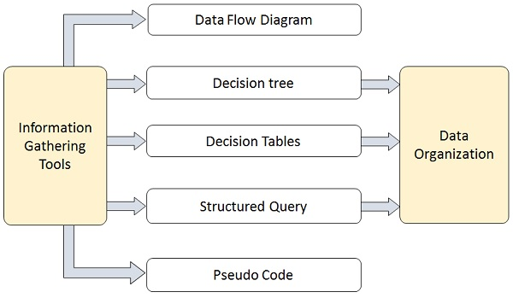
Data Flow Diagrams (DFD) or Bubble Chart
It is a technique developed by Larry Constantine to express the requirements of system in a graphical form.
- It shows the flow of data between various functions of system and specifies how the current system is implemented.
- It is an initial stage of design phase that functionally divides the requirement specifications down to the lowest level of detail.
- Its graphical nature makes it a good communication tool between user and analyst or analyst and system designer.
- It gives an overview of what data a system processes, what transformations are performed, what data are stored, what results are produced and where they flow.

Basic Elements of DFD:-
DFD is easy to understand and quite effective when the required design is not clear and the user wants a notational language for communication. However, it requires a large number of iterations for obtaining the most accurate and complete solution.
The following table shows the symbols used in designing a DFD and their significance −
Symbol Name | Symbol | Meaning
Square |  | Source or Destination of Data
Arrow | 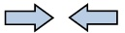 | Data flow
Circle | 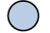 | Process transforming data flow
Open Rectangle | 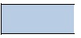 | Data Store

Types of DFD:-
DFDs are of two types: Physical DFD and Logical DFD. The following table lists the points that differentiate a physical DFD from a logical DFD.

Physical DFD | Logical DFD
It is implementation dependent. It shows which functions are performed. | It is implementation independent. It focuses only on the flow of data between processes.
It provides low level details of hardware, software, files, and people. | It explains events of systems and data required by each event.
It depicts how the current system operates and how a system will be implemented. | It shows how business operates; not how the system can be implemented.

Context Diagram:-
A context diagram helps in understanding the entire system by one DFD which gives the overview of a system. It starts with mentioning major processes with little details and then goes onto giving more details of the processes with the top-down approach.
The context diagram of mess management is shown below.
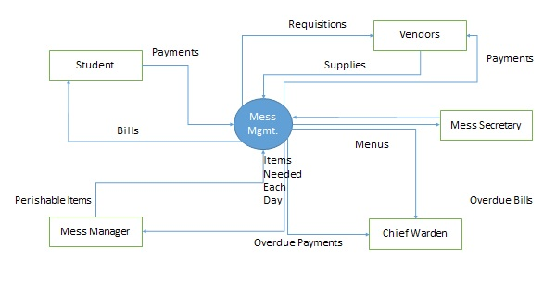
Data Dictionary:-
A data dictionary is a structured repository of data elements in the system. It stores the descriptions of all DFD data elements that is, details and definitions of data flows, data stores, data stored in data stores, and the processes.
A data dictionary improves the communication between the analyst and the user. It plays an important role in building a database. Most DBMSs have a data dictionary as a standard feature. For example, refer the following table –

Sr.No. | Data Name | Description | No. of Characters
1 | ISBN | ISBN Number | 10
2 | TITLE | title | 60
3 | SUB | Book Subjects | 80
4 | ANAME | Author Name | 15

Decision Trees :-
Decision trees are a method for defining complex relationships by describing decisions and avoiding the problems in communication. A decision tree is a diagram that shows alternative actions and conditions within horizontal tree framework. Thus, it depicts which conditions to consider first, second, and so on.
Decision trees depict the relationship of each condition and their permissible actions. A square node indicates an action and a circle indicates a condition. It forces analysts to consider the sequence of decisions and identifies the actual decision that must be made.
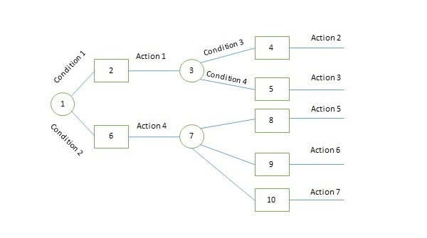
The major limitation of a decision tree is that it lacks information in its format to describe what other combinations of conditions you can take for testing. It is a single representation of the relationships between conditions and actions.
For example, refer the following decision tree −
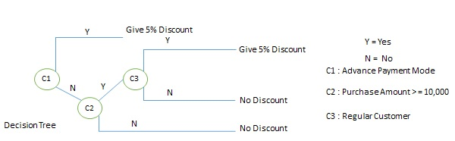

Decision Tables :-
Decision tables are a method of describing the complex logical relationship in a precise manner which is easily understandable.
- It is useful in situations where the resulting actions depend on the occurrence of one or several combinations of independent conditions.
- It is a matrix containing row or columns for defining a problem and the actions.

Pseudocode:-
A pseudocode does not conform to any programming language and expresses logic in plain English.
- It may specify the physical programming logic without actual coding during and after the physical design.
- It is used in conjunction with structured programming.
- It replaces the flowcharts of a program.

- 1.1.1 Basic System Development Life Cycle with different users and their role in SDLC :-

Software Development Life Cycle, SDLC for short, is a well-defined, structured sequence of stages in software engineering to develop the intended software product.

SDLC Activities
SDLC provides a series of steps to be followed to design and develop a software product efficiently. SDLC framework includes the following steps:
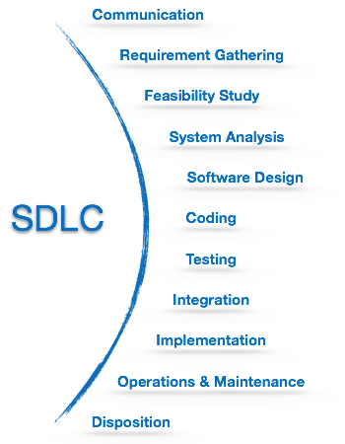

Communication :-
This is the first step where the user initiates the request for a desired software product. He contacts the service provider and tries to negotiate the terms. He submits his request to the service providing organization in writing.
Requirement Gathering
This step onwards the software development team works to carry on the project. The team holds discussions with various stakeholders from problem domain and tries to bring out as much information as possible on their requirements. The requirements are contemplated and segregated into user requirements, system requirements and functional requirements. The requirements are collected using a number of practices as given -
- studying the existing or obsolete system and software,
- conducting interviews of users and developers,
- referring to the database or
- collecting answers from the questionnaires.

Feasibility Study:-
After requirement gathering, the team comes up with a rough plan of software process. At this step the team analyzes if a software can be made to fulfill all requirements of the user and if there is any possibility of software being no more useful. It is found out, if the project is financially, practically and technologically feasible for the organization to take up. There are many algorithms available, which help the developers to conclude the feasibility of a software project.

System Analysis :-
At this step the developers decide a roadmap of their plan and try to bring up the best software model suitable for the project. System analysis includes Understanding of software product limitations, learning system related problems or changes to be done in existing systems beforehand, identifying and addressing the impact of project on organization and personnel etc. The project team analyzes the scope of the project and plans the schedule and resources accordingly.

Software Design:-
Next step is to bring down whole knowledge of requirements and analysis on the desk and design the software product. The inputs from users and information gathered in requirement gathering phase are the inputs of this step. The output of this step comes in the form of two designs; logical design and physical design. Engineers produce meta-data and data dictionaries, logical diagrams, data-flow diagrams and in some cases pseudo codes.

Coding:-
This step is also known as programming phase. The implementation of software design starts in terms of writing program code in the suitable programming language and developing error-free executable programs efficiently.

Testing:-
An estimate says that 50% of whole software development process should be tested. Errors may ruin the software from critical level to its own removal. Software testing is done while coding by the developers and thorough testing is conducted by testing experts at various levels of code such as module testing, program testing, product testing, in-house testing and testing the product at user’s end. Early discovery of errors and their remedy is the key to reliable software.

Integration:-
Software may need to be integrated with the libraries, databases and other program(s). This stage of SDLC is involved in the integration of software with outer world entities.

Implementation:-
This means installing the software on user machines. At times, software needs post-installation configurations at user end. Software is tested for portability and adaptability and integration related issues are solved during implementation.

Operation and Maintenance:-
This phase confirms the software operation in terms of more efficiency and less errors. If required, the users are trained on, or aided with the documentation on how to operate the software and how to keep the software operational. The software is maintained timely by updating the code according to the changes taking place in user end environment or technology. This phase may face challenges from hidden bugs and real-world unidentified problems.

Disposition:-
As time elapses, the software may decline on the performance front. It may go completely obsolete or may need intense up gradation. Hence a pressing need to eliminate a major portion of the system arises. This phase includes archiving data and required software components, closing down the system, planning disposition activity and terminating system at appropriate end-of-system time.

What is SDLC?
SDLC is a process followed for a software project, within a software organization. It consists of a detailed plan describing how to develop, maintain, replace and alter or enhance specific software. The life cycle defines a methodology for improving the quality of software and the overall development process.
The following figure is a graphical representation of the various stages of a typical SDLC.
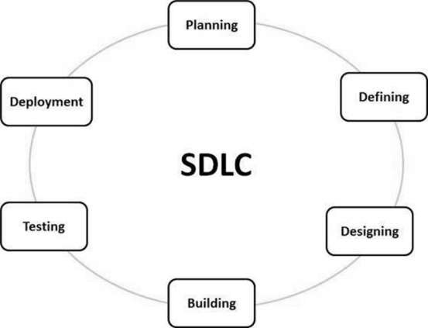
A typical Software Development Life Cycle consists of the following stages:

Stage 1: Planning and Requirement Analysis:-
Requirement analysis is the most important and fundamental stage in SDLC. It is performed by the senior members of the team with inputs from the customer, the sales department, market surveys and domain experts in the industry. This information is then used to plan the basic project approach and to conduct product feasibility study in the economical, operational and technical areas.
Planning for the quality assurance requirements and identification of the risks associated with the project is also done in the planning stage. The outcome of the technical feasibility study is to define the various technical approaches that can be followed to implement the project successfully with minimum risks.

Stage 2: Defining Requirements :-
Once the requirement analysis is done the next step is to clearly define and document the product requirements and get them approved from the customer or the market analysts. This is done through an SRS (Software Requirement Specification) document which consists of all the product requirements to be designed and developed during the project life cycle.

Stage 3: Designing the Product Architecture:-
SRS is the reference for product architects to come out with the best architecture for the product to be developed. Based on the requirements specified in SRS, usually more than one design approach for the product architecture is proposed and documented in a DDS - Design Document Specification.
This DDS is reviewed by all the important stakeholders and based on various parameters as risk assessment, product robustness, design modularity, budget and time constraints, the best design approach is selected for the product.
A design approach clearly defines all the architectural modules of the product along with its communication and data flow representation with the external and third party modules (if any). The internal design of all the modules of the proposed architecture should be clearly defined with the minutest of the details in DDS.

Stage 4: Building or Developing the Product :-
In this stage of SDLC the actual development starts and the product is built. The programming code is generated as per DDS during this stage. If the design is performed in a detailed and organized manner, code generation can be accomplished without much hassle.
Developers must follow the coding guidelines defined by their organization and programming tools like compilers, interpreters, debuggers, etc. are used to generate the code. Different high level programming languages such as C, C++, Pascal, Java and PHP are used for coding. The programming language is chosen with respect to the type of software being developed.
Stage 5: Testing the Product :-
This stage is usually a subset of all the stages as in the modern SDLC models, the testing activities are mostly involved in all the stages of SDLC. However, this stage refers to the testing only stage of the product where product defects are reported, tracked, fixed and retested, until the product reaches the quality standards defined in the SRS.

Stage 6: Deployment in the Market and Maintenance:-
Once the product is tested and ready to be deployed it is released formally in the appropriate market. Sometimes product deployment happens in stages as per the business strategy of that organization. The product may first be released in a limited segment and tested in the real business environment (UAT- User acceptance testing).
Then based on the feedback, the product may be released as it is or with suggested enhancements in the targeting market segment. After the product is released in the market, its maintenance is done for the existing customer base.

An effective System Development Life Cycle (SDLC) should result in a high quality system that meets customer expectations, reaches completion within time and cost evaluations, and works effectively and efficiently in the current and planned Information Technology infrastructure.
System Development Life Cycle (SDLC) is a conceptual model which includes policies and procedures for developing or altering systems throughout their life cycles.
SDLC is used by analysts to develop an information system. SDLC includes the following activities −
- requirements
- design
- implementation
- testing
- deployment
- operations
- maintenance
Phases of SDLC
Systems Development Life Cycle is a systematic approach which explicitly breaks down the work into phases that are required to implement either new or modified Information System.
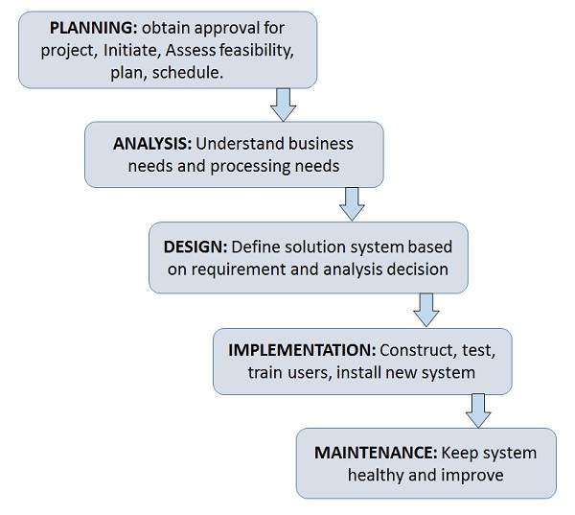

Feasibility Study or Planning:-
- Define the problem and scope of existing system.
- Overview the new system and determine its objectives.
- Confirm project feasibility and produce the project Schedule.
- During this phase, threats, constraints, integration and security of system are also considered.
- A feasibility report for the entire project is created at the end of this phase.

Analysis and Specification:-
- Gather, analyze, and validate the information.
- Define the requirements and prototypes for new system.
- Evaluate the alternatives and prioritize the requirements.
- Examine the information needs of end-user and enhances the system goal.
- A Software Requirement Specification (SRS) document, which specifies the software, hardware, functional, and network requirements of the system is prepared at the end of this phase.

System Design:-
- Includes the design of application, network, databases, user interfaces, and system interfaces.
- Transform the SRS document into logical structure, which contains detailed and complete set of specifications that can be implemented in a programming language.
- Create a contingency, training, maintenance, and operation plan.
- Review the proposed design. Ensure that the final design must meet the requirements stated in SRS document.
- Finally, prepare a design document which will be used during next phases.

Implementation:-
- Implement the design into source code through coding.
- Combine all the modules together into training environment that detects errors and defects.
- A test report which contains errors is prepared through test plan that includes test related tasks such as test case generation, testing criteria, and resource allocation for testing.
- Integrate the information system into its environment and install the new system.

Maintenance/Support:-
- Include all the activities such as phone support or physical on-site support for users that is required once the system is installing.
- Implement the changes that software might undergo over a period of time, or implement any new requirements after the software is deployed at the customer location.
- It also includes handling the residual errors and resolve any issues that may exist in the system even after the testing phase.
- Maintenance and support may be needed for a longer time for large systems and for a short time for smaller systems.

Life Cycle of System Analysis and Design:-
The following diagram shows the complete life cycle of the system during analysis and design phase.
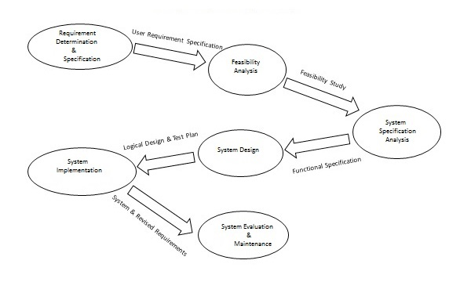

Role of System Analyst:-
The system analyst is a person who is thoroughly aware of the system and guides the system development project by giving proper directions. He is an expert having technical and interpersonal skills to carry out development tasks required at each phase.
He pursues to match the objectives of information system with the organization goal.
Main Roles
- Defining and understanding the requirement of user through various Fact finding techniques.
- Prioritizing the requirements by obtaining user consensus.
- Gathering the facts or information and acquires the opinions of users.
- Maintains analysis and evaluation to arrive at appropriate system which is more user friendly.
- Suggests many flexible alternative solutions, pick the best solution, and quantify cost and benefits.
- Draw certain specifications which are easily understood by users and programmer in precise and detailed form.
- Implemented the logical design of system which must be modular.
- Plan the periodicity for evaluation after it has been used for some time, and modify the system as needed.
Attributes of a Systems Analyst
The following figure shows the attributes a systems analyst should possess −
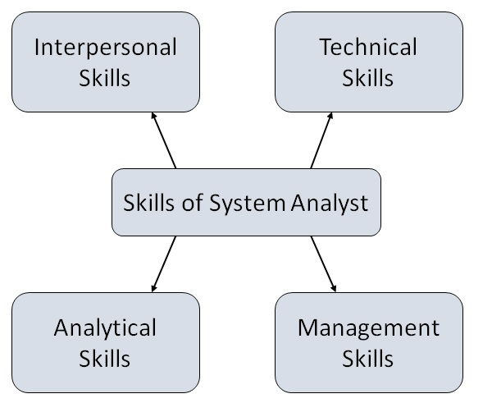

Interpersonal Skills:-
- Interface with users and programmer.
- Facilitate groups and lead smaller teams.
- Managing expectations.
- Good understanding, communication, selling and teaching abilities.
- Motivator having the confidence to solve queries.
Analytical Skills:-
- System study and organizational knowledge
- Problem identification, problem analysis, and problem solving
- Sound commonsense
- Ability to access trade-off
- Curiosity to learn about new organization

Management Skills:-
- Understand users jargon and practices.
- Resource & project management.
- Change & risk management.
- Understand the management functions thoroughly.

Technical Skills:-
- Knowledge of computers and software.
- Keep abreast of modern development.
- Know of system design tools.
- Breadth knowledge about new technologies.

What is Requirements Determination?
A requirement is a vital feature of a new system which may include processing or capturing of data, controlling the activities of business, producing information and supporting the management.
Requirements determination involves studying the existing system and gathering details to find out what are the requirements, how it works, and where improvements should be made.
Major Activities in requirement Determination
Requirements Anticipation
- It predicts the characteristics of system based on previous experience which include certain problems or features and requirements for a new system.
- It can lead to analysis of areas that would otherwise go unnoticed by inexperienced analyst. But if shortcuts are taken and bias is introduced in conducting the investigation, then requirement Anticipation can be half-baked.
Requirements Investigation
- It is studying the current system and documenting its features for further analysis.
- It is at the heart of system analysis where analyst documenting and describing system features using fact-finding techniques, prototyping, and computer assisted tools.
Requirements Specifications
- It includes the analysis of data which determine the requirement specification, description of features for new system, and specifying what information requirements will be provided.
- It includes analysis of factual data, identification of essential requirements, and selection of Requirement-fulfillment strategies.
Information Gathering Techniques
The main aim of fact finding techniques is to determine the information requirements of an organization used by analysts to prepare a precise SRS understood by user.
Ideal SRS Document should −
- be complete, Unambiguous, and Jargon-free.
- specify operational, tactical, and strategic information requirements.
- solve possible disputes between users and analyst.
- use graphical aids which simplify understanding and design.
There are various information gathering techniques −
Interviewing
Systems analyst collects information from individuals or groups by interviewing. The analyst can be formal, legalistic, play politics, or be informal; as the success of an interview depends on the skill of analyst as interviewer.
It can be done in two ways −
- Unstructured Interview − The system analyst conducts question-answer session to acquire basic information of the system.
- Structured Interview − It has standard questions which user need to respond in either close (objective) or open (descriptive) format.
Advantages of Interviewing
- This method is frequently the best source of gathering qualitative information.
- It is useful for them, who do not communicate effectively in writing or who may not have the time to complete questionnaire.
- Information can easily be validated and cross checked immediately.
- It can handle the complex subjects.
- It is easy to discover key problem by seeking opinions.
- It bridges the gaps in the areas of misunderstandings and minimizes future problems.
Questionnaires
This method is used by analyst to gather information about various issues of system from large number of persons.
There are two types of questionnaires −
- Open-ended Questionnaires − It consists of questions that can be easily and correctly interpreted. They can explore a problem and lead to a specific direction of answer.
- Closed-ended Questionnaires − It consists of questions that are used when the systems analyst effectively lists all possible responses, which are mutually exclusive.
Advantages of questionnaires
- It is very effective in surveying interests, attitudes, feelings, and beliefs of users which are not co-located.
- It is useful in situation to know what proportion of a given group approves or disapproves of a particular feature of the proposed system.
- It is useful to determine the overall opinion before giving any specific direction to the system project.
- It is more reliable and provides high confidentiality of honest responses.
- It is appropriate for electing factual information and for statistical data collection which can be emailed and sent by post.
Review of Records, Procedures, and Forms
Review of existing records, procedures, and forms helps to seek insight into a system which describes the current system capabilities, its operations, or activities.
Advantages
- It helps user to gain some knowledge about the organization or operations by themselves before they impose upon others.
- It helps in documenting current operations within short span of time as the procedure manuals and forms describe the format and functions of present system.
- It can provide a clear understanding about the transactions that are handled in the organization, identifying input for processing, and evaluating performance.
- It can help an analyst to understand the system in terms of the operations that must be supported.
- It describes the problem, its affected parts, and the proposed solution.
Observation
This is a method of gathering information by noticing and observing the people, events, and objects. The analyst visits the organization to observe the working of current system and understands the requirements of the system.
Advantages
- It is a direct method for gleaning information.
- It is useful in situation where authenticity of data collected is in question or when complexity of certain aspects of system prevents clear explanation by end-users.
- It produces more accurate and reliable data.
- It produces all the aspect of documentation that are incomplete and outdated.
Feasibility Study
Feasibility Study can be considered as preliminary investigation that helps the management to take decision about whether study of system should be feasible for development or not.
- It identifies the possibility of improving an existing system, developing a new system, and produce refined estimates for further development of system.
- It is used to obtain the outline of the problem and decide whether feasible or appropriate solution exists or not.
- The main objective of a feasibility study is to acquire problem scope instead of solving the problem.
- The output of a feasibility study is a formal system proposal act as decision document which includes the complete nature and scope of the proposed system.
Steps Involved in Feasibility Analysis
The following steps are to be followed while performing feasibility analysis −
- Form a project team and appoint a project leader.
- Develop system flowcharts.
- Identify the deficiencies of current system and set goals.
- Enumerate the alternative solution or potential candidate system to meet goals.
- Determine the feasibility of each alternative such as technical feasibility, operational feasibility, etc.
- Weight the performance and cost effectiveness of each candidate system.
- Rank the other alternatives and select the best candidate system.
- Prepare a system proposal of final project directive to management for approval.
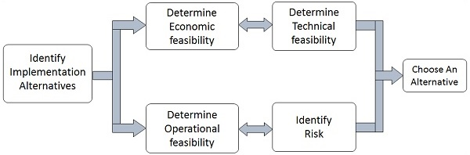
Types of Feasibilities

Economic Feasibility:-
- It is evaluating the effectiveness of candidate system by using cost/benefit analysis method.
- It demonstrates the net benefit from the candidate system in terms of benefits and costs to the organization.
- The main aim of Economic Feasibility Analysis (EFS) is to estimate the economic requirements of candidate system before investments funds are committed to proposal.
- It prefers the alternative which will maximize the net worth of organization by earliest and highest return of funds along with lowest level of risk involved in developing the candidate system.

Technical Feasibility:-
- It investigates the technical feasibility of each implementation alternative.
- It analyzes and determines whether the solution can be supported by existing technology or not.
- The analyst determines whether current technical resources be upgraded or added it that fulfill the new requirements.
- It ensures that the candidate system provides appropriate responses to what extent it can support the technical enhancement.

Operational Feasibility:-
- It determines whether the system is operating effectively once it is developed and implemented.
- It ensures that the management should support the proposed system and its working feasible in the current organizational environment.
- It analyzes whether the users will be affected and they accept the modified or new business methods that affect the possible system benefits.
- It also ensures that the computer resources and network architecture of candidate system are workable.

Behavioral Feasibility:-
- It evaluates and estimates the user attitude or behavior towards the development of new system.
- It helps in determining if the system requires special effort to educate, retrain, transfer, and changes in employee’s job status on new ways of conducting business.

Schedule Feasibility:-
- It ensures that the project should be completed within given time constraint or schedule.
- It also verifies and validates whether the deadlines of project are reasonable or not.

Responsibilities of the Project Manager :-
- Determine objectives, schedule and resource budgets
- Design a software project management plan (SPMP)
- Create and sustain focused and motivated teams
- Determine the team‘s work procedures, reporting systems and communication infrastructure.
- Accomplish project objective within time and budget
- Monitor performance against the plan
- Resolve technical conflicts and interpersonal conflicts
- Control changes in the project
- Report on project activities to upper management
- Keep the client informed and committed
- Contribute to the team members performance approval

Responsibilities of the Team Leader :-
- Run the weekly project meeting
- Post the agenda before the meeting
- Define and keep track of action items assigned to team members (who, what, when)
- Measure progress (Enforce milestones)
- Deliver work packages for the tasks to the project manager
- Present team status to project manager
Technical team responsibilities:
- Perform assigned tasks within time and budget
- Acquire technical skills and knowledge needed to perform the work
- Identify situations and problems that might affect your team members‘s tasks Keep your team members informed of your progress and problems you encounter

Responsibilities of a Tester:-
The roles and responsibilities of a tester often vary from organization to organization. In general, a testers main purpose is to design, develop, and conduct system tests and supports acceptance testing. The roles and responsibilities of a tester include the core activities associated with the test effort. This usually involves identifying the most appropriate implementation approach specific tests, performing test preparations, executing the tests, logging outcomes, and administering the defect tracking system.
More detailed aspects of the roles and responsibilities of a tester is included in the following:
- Analyzing client requirements
- Understand the software application being tested
- Prepare test strategy
- Participating in test plan preparation
- Preparing test scenarios
- Preparing test cases (used for module, integration, and system testing
- Preparing test data (used for test cases)
- Preparing test environment
- Analyzing test cases (those prepared by others)
- Write necessary test scripts
- Executing the test cases
- Defect tracking
- Perform necessary retesting
- Providing defect information (for developers)
- Preparing report summaries
- Preparing lesson learnt documents
- Conducting review meetings within the team

The testing in this phase can involve many different types of tests, depending on the project and the company, such as:
- Unit testing: testing individual pieces of code to ensure they work
- System testing: testing the entire system to ensure it works
- Verification testing: ensure that the system does what the requirements say it should do
- Integration testing: ensure that the system communicates to other systems correctly
- Regression testing: make sure that nothing else is broken when this is implemented after making changes (Impact Analysis Testing).

- 1.1.2. Different Approaches and Models for System Development:-

- 1.1.2.1. Waterfall Model

Waterfall model is the simplest model of software development paradigm. It says the all the phases of SDLC will function one after another in linear manner. That is, when the first phase is finished then only the second phase will start and so on.
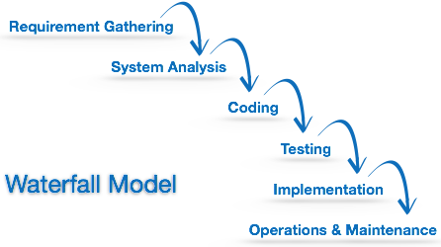
This model assumes that everything is carried out and taken place perfectly as planned in the previous stage and there is no need to think about the past issues that may arise in the next phase. This model does not work smoothly if there are some issues left at the previous step. The sequential nature of model does not allow us go back and undo or redo our actions.
This model is best suited when developers already have designed and developed similar software in the past and are aware of all its domains.

The Waterfall Model was the first Process Model to be introduced. It is also referred to as a linear-sequential life cycle model. It is very simple to understand and use. In a waterfall model, each phase must be completed before the next phase can begin and there is no overlapping in the phases.
The Waterfall model is the earliest SDLC approach that was used for software development.
The waterfall Model illustrates the software development process in a linear sequential flow. This means that any phase in the development process begins only if the previous phase is complete. In this waterfall model, the phases do not overlap.
Waterfall Model - Design
Waterfall approach was first SDLC Model to be used widely in Software Engineering to ensure success of the project. In "The Waterfall" approach, the whole process of software development is divided into separate phases. In this Waterfall model, typically, the outcome of one phase acts as the input for the next phase sequentially.
The following illustration is a representation of the different phases of the Waterfall Model.
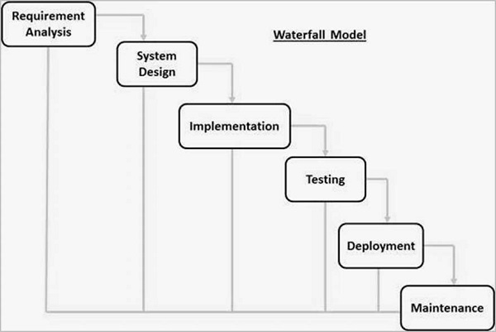
The sequential phases in Waterfall model are −
Requirement Gathering and analysis − All possible requirements of the system to be developed are captured in this phase and documented in a requirement specification document.
System Design − The requirement specifications from first phase are studied in this phase and the system design is prepared. This system design helps in specifying hardware and system requirements and helps in defining the overall system architecture.
Implementation − With inputs from the system design, the system is first developed in small programs called units, which are integrated in the next phase. Each unit is developed and tested for its functionality, which is referred to as Unit Testing.
Integration and Testing − All the units developed in the implementation phase are integrated into a system after testing of each unit. Post integration the entire system is tested for any faults and failures.
Deployment of system − Once the functional and non-functional testing is done; the product is deployed in the customer environment or released into the market.
Maintenance − There are some issues which come up in the client environment. To fix those issues, patches are released. Also to enhance the product some better versions are released. Maintenance is done to deliver these changes in the customer environment.
All these phases are cascaded to each other in which progress is seen as flowing steadily downwards (like a waterfall) through the phases. The next phase is started only after the defined set of goals are achieved for previous phase and it is signed off, so the name "Waterfall Model". In this model, phases do not overlap.
Waterfall Model - Application
Every software developed is different and requires a suitable SDLC approach to be followed based on the internal and external factors. Some situations where the use of Waterfall model is most appropriate are −
- Requirements are very well documented, clear and fixed.
- Product definition is stable.
- Technology is understood and is not dynamic.
- There are no ambiguous requirements.
- Ample resources with required expertise are available to support the product.
- The project is short.

WATERFALL MODEL is a sequential model that divides software development into pre-defined phases. Each phase must be completed before the next phase can begin with no overlap between the phases. Each phase is designed for performing specific activity during the SDLC phase. It was introduced in 1970 by Winston Royce.
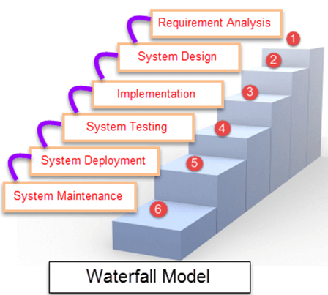
Different Phases of Waterfall Model in Software Engineering
Different phases | Activities performed in each stage
Requirement Gathering stage | - During this phase, detailed requirements of the software system to be developed are gathered from client
Design Stage | - Plan the programming language, for Example Java, PHP, .net  - or database like Oracle, MySQL, etc.  - Or other high-level technical details of the project
Built Stage | - After design stage, it is built stage, that is nothing but coding the software
Test Stage | - In this phase, you test the software to verify that it is built as per the specifications given by the client.
Deployment stage | - Deploy the application in the respective environment
Maintenance stage | - Once your system is ready to use, you may later require change the code as per customer request

- When to use SDLC Waterfall Model :-
- Requirements are not changing frequently
- Application is not complicated and big
- Project is short
- Requirement is clear
- Environment is stable
- Technology and tools used are not dynamic and is stable
- Resources are available and trained

- Waterfall Model - Advantages

The advantages of waterfall development are that it allows for departmentalization and control. A schedule can be set with deadlines for each stage of development and a product can proceed through the development process model phases one by one.
Development moves from concept, through design, implementation, testing, installation, troubleshooting, and ends up at operation and maintenance. Each phase of development proceeds in strict order.

Some of the major advantages of the Waterfall Model are as follows –

- Simple and easy to understand and use
- Easy to manage due to the rigidity of the model. Each phase has specific deliverables and a review process.
- Phases are processed and completed one at a time.
- Works well for smaller projects where requirements are very well understood.
- Clearly defined stages.
- Well understood milestones.
- Easy to arrange tasks.
- Process and results are well documented.

- This model is simple to implement also the number of resources that are required for it is minimal.
- The requirements are simple and explicitly declared; they remain unchanged during the entire project development.
- The start and end points for each phase is fixed, which makes it easy to cover progress.
- The release date for the complete product, as well as its final cost, can be determined before development.
- It gives easy to control and clarity for the customer due to a strict reporting system.

- Waterfall Model - Disadvantages

The disadvantage of waterfall development is that it does not allow much reflection or revision. Once an application is in the testing stage, it is very difficult to go back and change something that was not well-documented or thought upon in the concept stage.

The major disadvantages of the Waterfall Model are as follows −
- No working software is produced until late during the life cycle.
- High amounts of risk and uncertainty.
- Not a good model for complex and object-oriented projects.
- Poor model for long and ongoing projects.
- Not suitable for the projects where requirements are at a moderate to high risk of changing. So, risk and uncertainty is high with this process model.
- It is difficult to measure progress within stages.
- Cannot accommodate changing requirements.
- Adjusting scope during the life cycle can end a project.
- Integration is done as a "big-bang. at the very end, which doesn't allow identifying any technological or business bottleneck or challenges early.

- In this model, the risk factor is higher, so this model is not suitable for more significant and complex projects.
- This model cannot accept the changes in requirements during development.
- It becomes tough to go back to the phase. For example, if the application has now shifted to the coding phase, and there is a change in requirement, It becomes tough to go back and change it.
- Since the testing done at a later stage, it does not allow identifying the challenges and risks in the earlier phase, so the risk reduction strategy is difficult to prepare.

Advantages and Disadvantages of Waterfall-Model :-
Advantages | Dis-Advantages
- Before the next phase of development, each phase must be completed | - Error can be fixed only during the phase
- Suited for smaller projects where requirements are well defined | - It is not desirable for complex project where requirement changes frequently
- They should perform quality assurance test (Verification and Validation) before completing each stage | - Testing period comes quite late in the developmental process
- Elaborate documentation is done at every phase of the software's development cycle | - Documentation occupies a lot of time of developers and testers
- Project is completely dependent on project team with minimum client intervention | - Clients valuable feedback cannot be included with ongoing development phase
- Any changes in software is made during the process of the development | - Small changes or errors that arise in the completed software may cause a lot of problems

- Iterative Model:-
This model leads the software development process in iterations. It projects the process of development in cyclic manner repeating every step after every cycle of SDLC process.
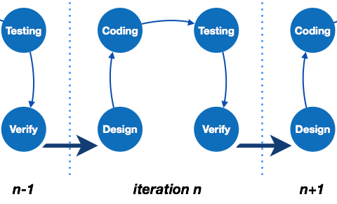
The software is first developed on very small scale and all the steps are followed which are taken into consideration. Then, on every next iteration, more features and modules are designed, coded, tested and added to the software. Every cycle produces a software, which is complete in itself and has more features and capabilities than that of the previous one.
After each iteration, the management team can do work on risk management and prepare for the next iteration. Because a cycle includes small portion of whole software process, it is easier to manage the development process but it consumes more resources.

In the Iterative model, iterative process starts with a simple implementation of a small set of the software requirements and iteratively enhances the evolving versions until the complete system is implemented and ready to be deployed.
An iterative life cycle model does not attempt to start with a full specification of requirements. Instead, development begins by specifying and implementing just part of the software, which is then reviewed to identify further requirements. This process is then repeated, producing a new version of the software at the end of each iteration of the model.

Iterative Model - Design
Iterative process starts with a simple implementation of a subset of the software requirements and iteratively enhances the evolving versions until the full system is implemented. At each iteration, design modifications are made and new functional capabilities are added. The basic idea behind this method is to develop a system through repeated cycles (iterative) and in smaller portions at a time (incremental).
The following illustration is a representation of the Iterative and Incremental model −
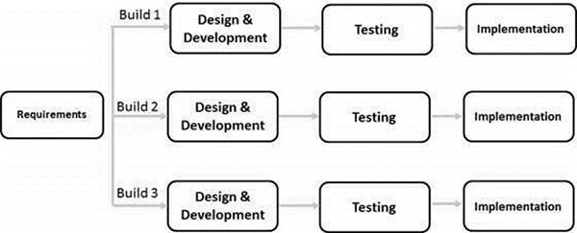

Iterative and Incremental development is a combination of both iterative design or iterative method and incremental build model for development. "During software development, more than one iteration of the software development cycle may be in progress at the same time." This process may be described as an "evolutionary acquisition" or "incremental build" approach."
In this incremental model, the whole requirement is divided into various builds. During each iteration, the development module goes through the requirements, design, implementation and testing phases. Each subsequent release of the module adds function to the previous release. The process continues till the complete system is ready as per the requirement.
The key to a successful use of an iterative software development lifecycle is rigorous validation of requirements, and verification & testing of each version of the software against those requirements within each cycle of the model. As the software evolves through successive cycles, tests must be repeated and extended to verify each version of the software.
Iterative Model - Application
Like other SDLC models, Iterative and incremental development has some specific applications in the software industry. This model is most often used in the following scenarios −
- Requirements of the complete system are clearly defined and understood.
- Major requirements must be defined; however, some functionalities or requested enhancements may evolve with time.
- There is a time to the market constraint.
- A new technology is being used and is being learnt by the development team while working on the project.
- Resources with needed skill sets are not available and are planned to be used on contract basis for specific iterations.
- There are some high-risk features and goals which may change in the future

What is Incremental Model?
Incremental Model is a process of software development where requirements are broken down into multiple standalone modules of software development cycle. Incremental development is done in steps from analysis design, implementation, testing/verification, maintenance.
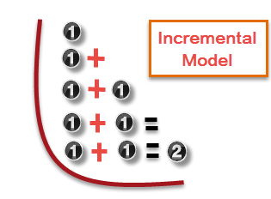
Each iteration passes through the requirements, design, coding and testing phases. And each subsequent release of the system adds function to the previous release until all designed functionality has been implemented.
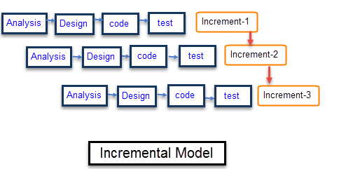
The system is put into production when the first increment is delivered. The first increment is often a core product where the basic requirements are addressed, and supplementary features are added in the next increments. Once the core product is analyzed by the client, there is plan development for the next increment.

Characteristics of an Incremental module includes
- System development is broken down into many mini development projects
- Partial systems are successively built to produce a final total system
- Highest priority requirement is tackled first
- Once the requirement is developed, requirement for that increment are frozen
Incremental Phases | Activities performed in incremental phases
Requirement Analysis | - Requirement and specification of the software are collected
Design | - Some high-end function are designed during this stage
Code | - Coding of software is done during this stage
Test | - Once the system is deployed, it goes through the testing phase
When to use Incremental models?
- Requirements of the system are clearly understood
- When demand for an early release of a product arises
- When software engineering team are not very well skilled or trained
- When high-risk features and goals are involved
- Such methodology is more in use for web application and product based companies

- Iterative Model - Pros and Cons :-
The advantage of this model is that there is a working model of the system at a very early stage of development, which makes it easier to find functional or design flaws. Finding issues at an early stage of development enables to take corrective measures in a limited budget.
The disadvantage with this SDLC model is that it is applicable only to large and bulky software development projects. This is because it is hard to break a small software system into further small serviceable increments/modules.

- The advantages of the Iterative and Incremental SDLC Model are as follows −
- Some working functionality can be developed quickly and early in the life cycle.
- Results are obtained early and periodically.
- Parallel development can be planned.
- Progress can be measured.
- Less costly to change the scope/requirements.
- Testing and debugging during smaller iteration is easy.
- Risks are identified and resolved during iteration; and each iteration is an easily managed milestone.
- Easier to manage risk - High risk part is done first.
- With every increment, operational product is delivered.
- Issues, challenges and risks identified from each increment can be utilized/applied to the next increment.
- Risk analysis is better.
- It supports changing requirements.
- Initial Operating time is less.
- Better suited for large and mission-critical projects.
- During the life cycle, software is produced early which facilitates customer evaluation and feedback.

- The disadvantages of the Iterative and Incremental SDLC Model are as follows −
- More resources may be required.
- Although cost of change is lesser, but it is not very suitable for changing requirements.
- More management attention is required.
- System architecture or design issues may arise because not all requirements are gathered in the beginning of the entire life cycle.
- Defining increments may require definition of the complete system.
- Not suitable for smaller projects.
- Management complexity is more.
- End of project may not be known which is a risk.
- Highly skilled resources are required for risk analysis.
- Projects progress is highly dependent upon the risk analysis phase.

Advantages and Disadvantages of Incremental Model
Advantages | Disadvantages
- The software will be generated quickly during the software life cycle | - It requires a good planning designing
- It is flexible and less expensive to change requirements and scope | - Problems might cause due to system architecture as such not all requirements collected up front for the entire software lifecycle
- Throughout the development stages changes can be done | - Each iteration phase is rigid and does not overlap each other
- This model is less costly compared to others | - Rectifying a problem in one unit requires correction in all the units and consumes a lot of time
- A customer can respond to each building
- Errors are easy to be identified

- 1.1.2.2 Spiral Model :-
Spiral model is a combination of both, iterative model and one of the SDLC model. It can be seen as if you choose one SDLC model and combine it with cyclic process (iterative model).
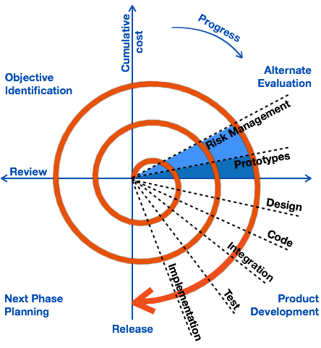

This model considers risk, which often goes un-noticed by most other models. The model starts with determining objectives and constraints of the software at the start of one iteration. Next phase is of prototyping the software. This includes risk analysis. Then one standard SDLC model is used to build the software. In the fourth phase of the plan of next iteration is prepared.

What is Spiral Model?
Spiral Model is a risk-driven software development process model. It is a combination of waterfall model and iterative model. Spiral Model helps to adopt software development elements of multiple process models for the software project based on unique risk patterns ensuring efficient development process.
Each phase of spiral model in software engineering begins with a design goal and ends with the client reviewing the progress. The spiral model in software engineering was first mentioned by Barry Boehm in his 1986 paper.
The development process in Spiral model in SDLC, starts with a small set of requirement and goes through each development phase for those set of requirements. The software engineering team adds functionality for the additional requirement in every-increasing spirals until the application is ready for the production phase. The below figure very well explain Spiral Model:
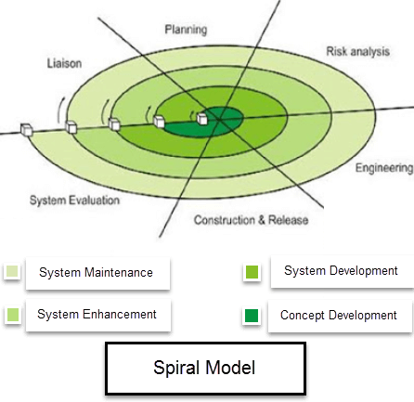Spiral Model Diagram
Spiral Model Phases
Spiral Model Phases | Activities performed during phase
Planning | - It includes estimating the cost, schedule and resources for the iteration. It also involves understanding the system requirements for continuous communication between the system analyst and the customer
Risk Analysis | - Identification of potential risk is done while risk mitigation strategy is planned and finalized
Engineering | - It includes testing, coding and deploying software at the customer site
Evaluation | - Evaluation of software by the customer. Also, includes identifying and monitoring risks such as schedule slippage and cost overrun

1.1.2.3. Prototyping Model :-
The prototype model requires that before carrying out the development of actual software, a working prototype of the system should be built. A prototype is a toy implementation of the system. A prototype usually turns out to be a very crude version of the actual system, possible exhibiting limited functional capabilities, low reliability, and inefficient performance as compared to actual software. In many instances, the client only has a general view of what is expected from the software product. In such a scenario where there is an absence of detailed information regarding the input to the system, the processing needs, and the output requirement, the prototyping model may be employed.
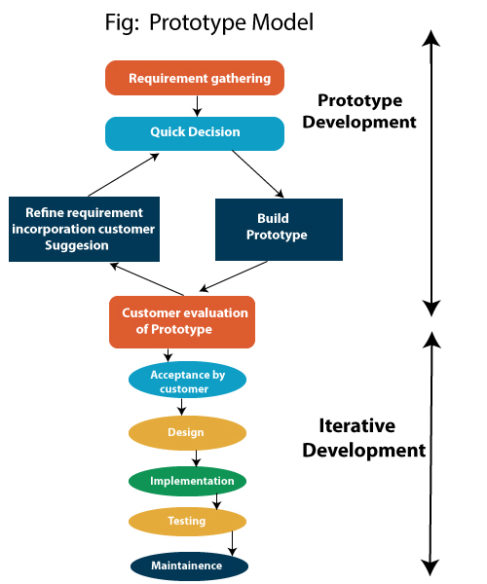

Prototyping Model is a software development model in which prototype is built, tested, and reworked until an acceptable prototype is achieved. It also creates base to produce the final system or software. It works best in scenarios where the project's requirements are not known in detail. It is an iterative, trial and error method which takes place between developer and client.

Prototyping Model Phases
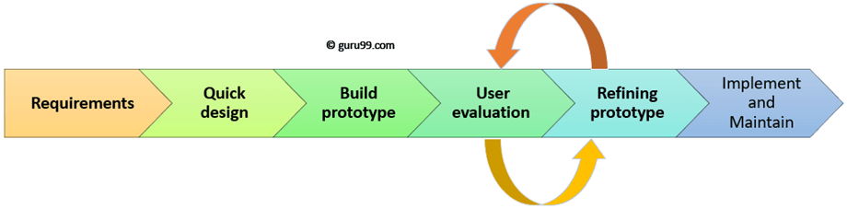
Prototyping Model has following six SDLC phases as follow:

Step 1: Requirements gathering and analysis
A prototyping model starts with requirement analysis. In this phase, the requirements of the system are defined in detail. During the process, the users of the system are interviewed to know what is their expectation from the system.

Step 2: Quick design
The second phase is a preliminary design or a quick design. In this stage, a simple design of the system is created. However, it is not a complete design. It gives a brief idea of the system to the user. The quick design helps in developing the prototype.

Step 3: Build a Prototype
In this phase, an actual prototype is designed based on the information gathered from quick design. It is a small working model of the required system.

Step 4: Initial user evaluation
In this stage, the proposed system is presented to the client for an initial evaluation. It helps to find out the strength and weakness of the working model. Comment and suggestion are collected from the customer and provided to the developer.

Step 5: Refining prototype
If the user is not happy with the current prototype, you need to refine the prototype according to the user's feedback and suggestions.
This phase will not over until all the requirements specified by the user are met. Once the user is satisfied with the developed prototype, a final system is developed based on the approved final prototype.

Step 6: Implement Product and Maintain
Once the final system is developed based on the final prototype, it is thoroughly tested and deployed to production. The system undergoes routine maintenance for minimizing downtime and prevent large-scale failures.

Software Prototyping - Application
Software Prototyping is most useful in development of systems having high level of user interactions such as online systems. Systems which need users to fill out forms or go through various screens before data is processed can use prototyping very effectively to give the exact look and feel even before the actual software is developed.
Software that involves too much of data processing and most of the functionality is internal with very little user interface does not usually benefit from prototyping. Prototype development could be an extra overhead in such projects and may need lot of extra efforts.

Prototyping is defined as the process of developing a working replication of a product or system that has to be engineered. It offers a small scale facsimile of the end product and is used for obtaining customer feedback as described below:

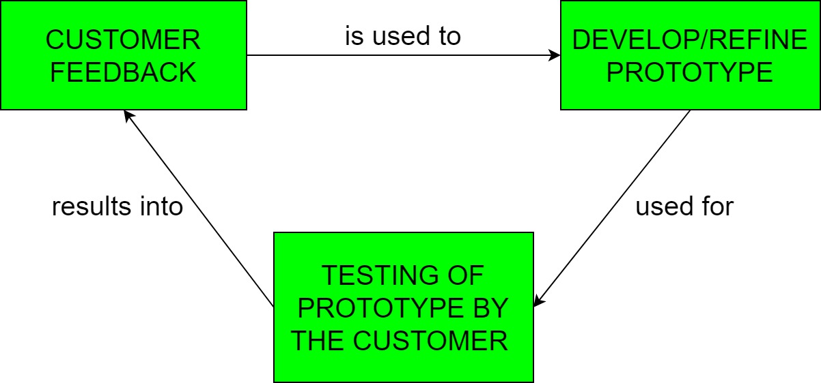

The Prototyping Model is one of the most popularly used Software Development Life Cycle Models (SDLC models).This model is used when the customers do not know the exact project requirements beforehand. In this model, a prototype of the end product is first developed, tested and refined as per customer feedback repeatedly till a final acceptable prototype is achieved which forms the basis for developing the final product.
In this process model, the system is partially implemented before or during the analysis phase thereby giving the customers an opportunity to see the product early in the life cycle. The process starts by interviewing the customers and developing the incomplete high-level paper model. This document is used to build the initial prototype supporting only the basic functionality as desired by the customer. Once the customer figures out the problems, the prototype is further refined to eliminate them. The process continues until the user approves the prototype and finds the working model to be satisfactory.

Types of Prototyping Models
Four types of Prototyping models are:
- Rapid Throwaway prototypes
- Evolutionary prototype
- Incremental prototype
- Extreme prototype

Rapid Throwaway Prototype :-
Rapid throwaway is based on the preliminary requirement. It is quickly developed to show how the requirement will look visually. The customer's feedback helps drives changes to the requirement, and the prototype is again created until the requirement is baselined.

In this method, a developed prototype will be discarded and will not be a part of the ultimately accepted prototype. This technique is useful for exploring ideas and getting instant feedback for customer requirements.

This technique offers a useful method of exploring ideas and getting customer feedback for each of them. In this method, a developed prototype need not necessarily be a part of the ultimately accepted prototype. Customer feedback helps in preventing unnecessary design faults and hence, the final prototype developed is of better quality.

Throwaway prototyping is also called as rapid or close ended prototyping. This type of prototyping uses very little efforts with minimum requirement analysis to build a prototype. Once the actual requirements are understood, the prototype is discarded and the actual system is developed with a much clear understanding of user requirements.

Evolutionary Prototyping :-
Here, the prototype developed is incrementally refined based on customer's feedback until it is finally accepted. It helps you to save time as well as effort. That's because developing a prototype from scratch for every interaction of the process can sometimes be very frustrating.
This model is helpful for a project which uses a new technology that is not well understood. It is also used for a complex project where every functionality must be checked once. It is helpful when the requirement is not stable or not understood clearly at the initial stage.

In this method, the prototype developed initially is incrementally refined on the basis of customer feedback till it finally gets accepted. In comparison to Rapid Throwaway Prototyping, it offers a better approach which saves time as well as effort. This is because developing a prototype from scratch for every iteration of the process can sometimes be very frustrating for the developers.

Evolutionary prototyping also called as breadboard prototyping is based on building actual functional prototypes with minimal functionality in the beginning. The prototype developed forms the heart of the future prototypes on top of which the entire system is built. By using evolutionary prototyping, the well-understood requirements are included in the prototype and the requirements are added as and when they are understood.

Evolutionary process model resembles the iterative enhancement model. The same phases are defined for the waterfall model occurs here in a cyclical fashion. This model differs from the iterative enhancement model in the sense that this does not require a useful product at the end of each cycle. In evolutionary development, requirements are implemented by category rather than by priority.

For example, in a simple database application, one cycle might implement the graphical user Interface (GUI), another file manipulation, another queries and another updates. All four cycles must complete before there is a working product available. GUI allows the users to interact with the system, file manipulation allow the data to be saved and retrieved, queries allow user to get out of the system, and updates allows users to put data into the system.

Incremental Prototyping :-
In incremental Prototyping, the final product is decimated into different small prototypes and developed individually. Eventually, the different prototypes are merged into a single product. This method is helpful to reduce the feedback time between the user and the application development team.

In this type of incremental Prototyping, the final expected product is broken into different small pieces of prototypes and being developed individually. In the end, when all individual pieces are properly developed, then the different prototypes are collectively merged into a single final product in their predefined order. It’s a very efficient approach which reduces the complexity of the development process, where the goal is divided into sub-parts and each sub-part is developed individually. The time interval between the project begin and final delivery is substantially reduced because all parts of the system are prototyped and tested simultaneously. Of course, there might be the possibility that the pieces just not fit together due to some lack ness in the development phase – this can only be fixed by careful and complete plotting of the entire system before prototyping starts.

Incremental prototyping refers to building multiple functional prototypes of the various sub-systems and then integrating all the available prototypes to form a complete system.

Extreme Prototyping:-

Extreme prototyping is used in the web development domain. It consists of three sequential phases. First, a basic prototype with all the existing pages is presented in the HTML format. Then the data processing is simulated using a prototype services layer. Finally, the services are implemented and integrated to the final prototype. This process is called Extreme Prototyping used to draw attention to the second phase of the process, where a fully functional UI is developed with very little regard to the actual services.

Extreme prototyping method is mostly used for web development. It is consists of three sequential phases.
- Basic prototype with all the existing page is present in the HTML format.
- You can simulate data process using a prototype services layer.
- The services are implemented and integrated into the final prototype.

This method is mainly used for web development. It is consists of three sequential independent phases:
1) In this phase a basic prototype with all the existing static pages are presented in the HTML format.
2) In the 2nd phase, Functional screens are made with a simulate data process using a prototype services layer.
3) This is the final step where all the services are implemented and associated with the final prototype.

This Extreme Prototyping method makes the project cycling and delivery robust and fast, and keeps the entire developer team focus centralized on products deliveries rather than discovering all possible needs and specifications and adding un-necessitated features.

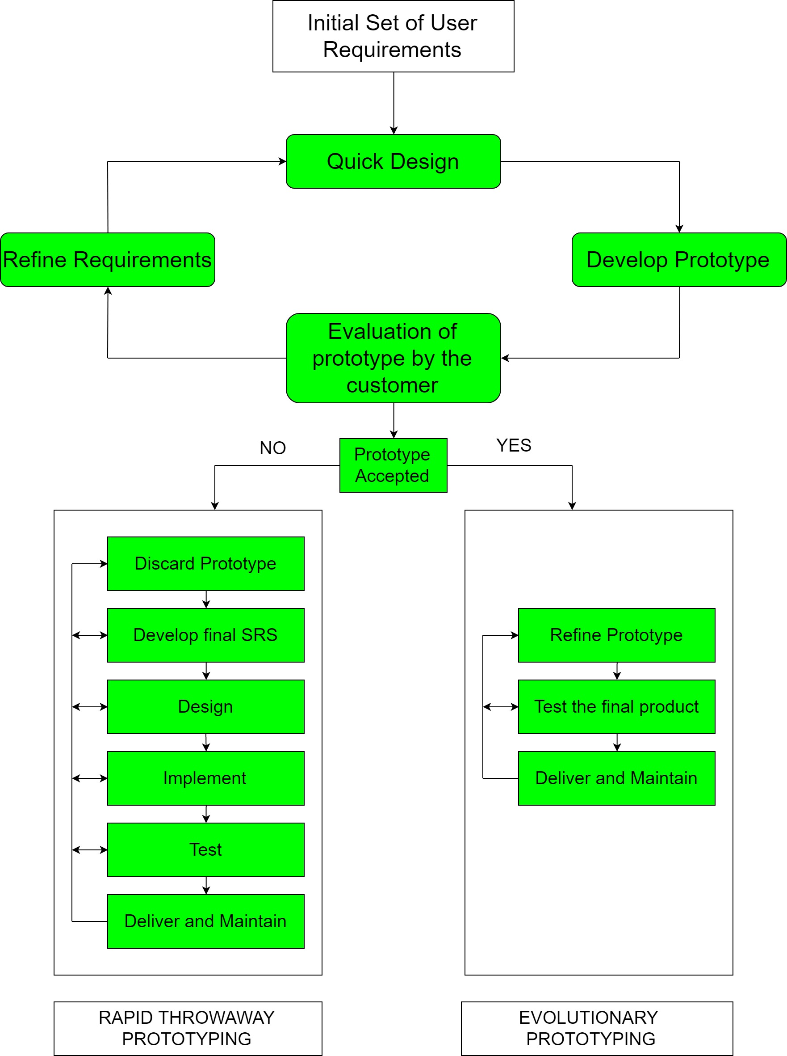
Best practices of Prototyping
Here, are a few things which you should watch for during the prototyping process:
- You should use Prototyping when the requirements are unclear
- It is important to perform planned and controlled Prototyping.
- Regular meetings are vital to keep the project on time and avoid costly delays.
- The users and the designers should be aware of the prototyping issues and pitfalls.
- At a very early stage, you need to approve a prototype and only then allow the team to move to the next step.
- In software prototyping method, you should never be afraid to change earlier decisions if new ideas need to be deployed.
- You should select the appropriate step size for each version.
- Implement important features early on so that if you run out of the time, you still have a worthwhile system

- Advantages of the Prototyping Model
Here, are important pros/benefits of using Prototyping models:

- Users are actively involved in development. Therefore, errors can be detected in the initial stage of the software development process.
- Missing functionality can be identified, which helps to reduce the risk of failure as Prototyping is also considered as a risk reduction activity.
- Helps team member to communicate effectively
- Customer satisfaction exists because the customer can feel the product at a very early stage.
- There will be hardly any chance of software rejection.
- Quicker user feedback helps you to achieve better software development solutions.
- Allows the client to compare if the software code matches the software specification.
- It helps you to find out the missing functionality in the system.
- It also identifies the complex or difficult functions.
- Encourages innovation and flexible designing.
- It is a straightforward model, so it is easy to understand.
- No need for specialized experts to build the model
- The prototype serves as a basis for deriving a system specification.
- The prototype helps to gain a better understanding of the customer's needs.
- Prototypes can be changed and even discarded.
- A prototype also serves as the basis for operational specifications.
- Prototypes may offer early training for future users of the software system.

- Reduce the risk of incorrect user requirement
- Good where requirement are changing/uncommitted
- Regular visible process aids management
- Support early product marketing
- Reduce Maintenance cost.
- Errors can be detected much earlier as the system is made side by side.

- Increased user involvement in the product even before its implementation.
- Since a working model of the system is displayed, the users get a better understanding of the system being developed.
- Reduces time and cost as the defects can be detected much earlier.
- Quicker user feedback is available leading to better solutions.
- Missing functionality can be identified easily.
- Confusing or difficult functions can be identified.

- The customers get to see the partial product early in the life cycle. This ensures a greater level of customer satisfaction and comfort.
- New requirements can be easily accommodated as there is scope for refinement.
- Missing functionalities can be easily figured out.
- Errors can be detected much earlier thereby saving a lot of effort and cost, besides enhancing the quality of the software.
- The developed prototype can be reused by the developer for more complicated projects in the future.
- Flexibility in design.

- Disadvantages of the Prototyping Model :-
Here, are important cons/drawbacks of prototyping model:

- Prototyping is a slow and time taking process.
- The cost of developing a prototype is a total waste as the prototype is ultimately thrown away.
- Prototyping may encourage excessive change requests.
- Some times customers may not be willing to participate in the iteration cycle for the longer time duration.
- There may be far too many variations in software requirements when each time the prototype is evaluated by the customer.
- Poor documentation because the requirements of the customers are changing.
- It is very difficult for software developers to accommodate all the changes demanded by the clients.
- After seeing an early prototype model, the customers may think that the actual product will be delivered to him soon.
- The client may lose interest in the final product when he or she is not happy with the initial prototype.
- Developers who want to build prototypes quickly may end up building sub-standard development solutions.
- An unstable/badly implemented prototype often becomes the final product.
- Require extensive customer collaboration
  - Costs customer money
  - Needs committed customer
  - Difficult to finish if customer withdraw
  - May be too customer specific, no broad market
- Difficult to know how long the project will last.
- Easy to fall back into the code and fix without proper requirement analysis, design, customer evaluation, and feedback.
- Prototyping tools are expensive.
- Special tools & techniques are required to build a prototype.
- It is a time-consuming process.
- Risk of insufficient requirement analysis owing to too much dependency on the prototype.
- Users may get confused in the prototypes and actual systems.
- Practically, this methodology may increase the complexity of the system as scope of the system may expand beyond original plans.
- Developers may try to reuse the existing prototypes to build the actual system, even when it is not technically feasible.
- The effort invested in building prototypes may be too much if it is not monitored properly.
- Costly with respect to time as well as money.
- There may be too much variation in requirements each time the prototype is evaluated by the customer.
- Poor Documentation due to continuously changing customer requirements.
- It is very difficult for developers to accommodate all the changes demanded by the customer.
- There is uncertainty in determining the number of iterations that would be required before the prototype is finally accepted by the customer.
- After seeing an early prototype, the customers sometimes demand the actual product to be delivered soon.
- Developers in a hurry to build prototypes may end up with sub-optimal solutions.
- The customer might lose interest in the product if he/she is not satisfied with the initial prototype.

Note:- The Prototyping Model should be used when the requirements of the product are not clearly understood or are unstable. It can also be used if requirements are changing quickly. This model can be successfully used for developing user interfaces, high technology software-intensive systems, and systems with complex algorithms and interfaces. It is also a very good choice to demonstrate the technical feasibility of the product.

1.1.2.4 RAD (Rapid Application Development) Model
RAD is a linear sequential software development process model that emphasizes a concise development cycle using an element based construction approach. If the requirements are well understood and described, and the project scope is a constraint, the RAD process enables a development team to create a fully functional system within a concise time period.

The RAD (Rapid Application Development) model is based on prototyping and iterative development with no specific planning involved. The process of writing the software itself involves the planning required for developing the product.
Rapid Application Development focuses on gathering customer requirements through workshops or focus groups, early testing of the prototypes by the customer using iterative concept, reuse of the existing prototypes (components), continuous integration and rapid delivery.
What is RAD?
Rapid application development is a software development methodology that uses minimal planning in favor of rapid prototyping. A prototype is a working model that is functionally equivalent to a component of the product.
In the RAD model, the functional modules are developed in parallel as prototypes and are integrated to make the complete product for faster product delivery. Since there is no detailed preplanning, it makes it easier to incorporate the changes within the development process.
RAD projects follow iterative and incremental model and have small teams comprising of developers, domain experts, customer representatives and other IT resources working progressively on their component or prototype.
The most important aspect for this model to be successful is to make sure that the prototypes developed are reusable

RAD (Rapid Application Development) is a concept that products can be developed faster and of higher quality through:
- Gathering requirements using workshops or focus groups
- Prototyping and early, reiterative user testing of designs
- The re-use of software components
- A rigidly paced schedule that refers design improvements to the next product version
- Less formality in reviews and other team communication
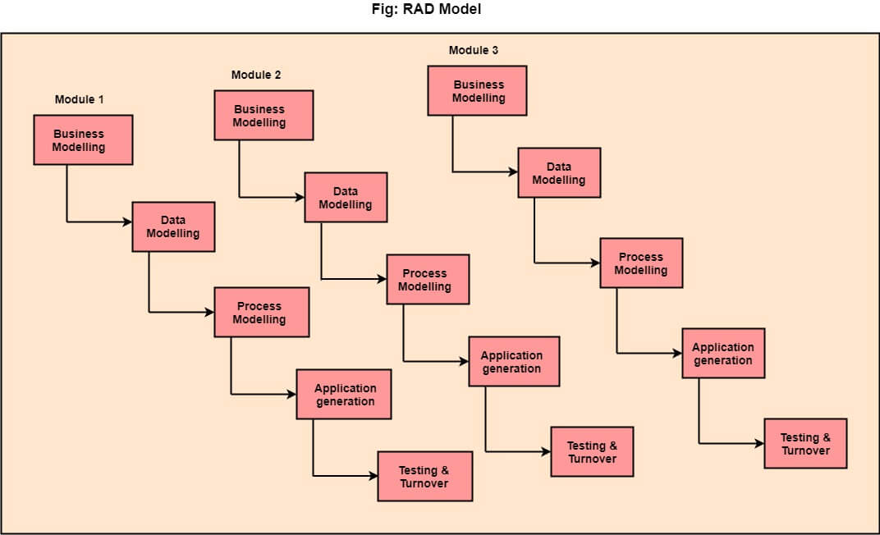

RAD Model or Rapid Application Development model is a software development process based on prototyping without any specific planning. In RAD model, there is less attention paid to the planning and more priority is given to the development tasks. It targets at developing software in a short span of time.
SDLC RAD modeling has following phases
- Business Modeling
- Data Modeling
- Process Modeling
- Application Generation
- Testing and Turnover
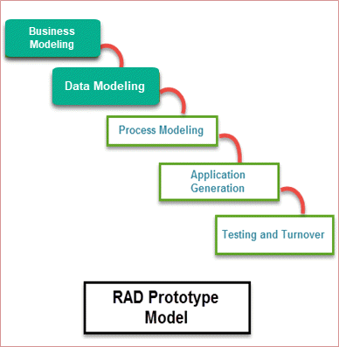

RAD Model Diagram

It focuses on input-output source and destination of the information. It emphasizes on delivering projects in small pieces; the larger projects are divided into a series of smaller projects. The main features of RAD modeling are that it focuses on the reuse of templates, tools, processes, and code.

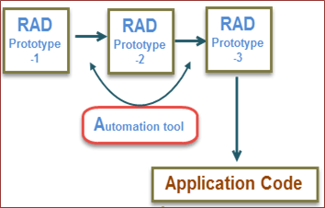
RAD Model in Software Engineering

Different Phases of RAD Model

There are following five major phases of Rapid Application Development Model
RAD Model Phases | Activities performed in RAD Modeling
Business Modeling | - On basis of the flow of information and distribution between various business channels, the product is designed
Data Modeling | - The information collected from business modeling is refined into a set of data objects that are significant for the business
Process Modeling | - The data object that is declared in the data modeling phase is transformed to achieve the information flow necessary to implement a business function
Application Generation | - Automated tools are used for the construction of the software, to convert process and data models into prototypes
Testing and Turnover | - As prototypes are individually tested during every iteration, the overall testing time is reduced in RAD.

The various phases of RAD are as follows:
1.Business Modeling: The information flow among business functions is defined by answering questions like what data drives the business process, what data is generated, who generates it, where does the information go, who process it and so on.
The business model for the product under development is designed in terms of flow of information and the distribution of information between various business channels. A complete business analysis is performed to find the vital information for business, how it can be obtained, how and when is the information processed and what are the factors driving successful flow of information.
2.Data Modeling: The data collected from business modeling is refined into a set of data objects (entities) that are needed to support the business. The attributes (character of each entity) are identified, and the relation between these data objects (entities) is defined.
The information gathered in the Business Modelling phase is reviewed and analyzed to form sets of data objects vital for the business. The attributes of all data sets is identified and defined. The relation between these data objects are established and defined in detail in relevance to the business model.
3. Process Modeling: The information object defined in the data modeling phase are transformed to achieve the data flow necessary to implement a business function. Processing descriptions are created for adding, modifying, deleting, or retrieving a data object.
The data object sets defined in the Data Modelling phase are converted to establish the business information flow needed to achieve specific business objectives as per the business model. The process model for any changes or enhancements to the data object sets is defined in this phase. Process descriptions for adding, deleting, retrieving or modifying a data object are given.
- Application Generation: Automated tools are used to facilitate construction of the software; even they use the 4th GL techniques.
The actual system is built and coding is done by using automation tools to convert process and data models into actual prototypes.
- Testing & Turnover: Many of the programming components have already been tested since RAD emphasis reuse. This reduces the overall testing time. But the new part must be tested, and all interfaces must be fully exercised.
The overall testing time is reduced in the RAD model as the prototypes are independently tested during every iteration. However, the data flow and the interfaces between all the components need to be thoroughly tested with complete test coverage. Since most of the programming components have already been tested, it reduces the risk of any major issues.
The following illustration describes the RAD Model in detail.

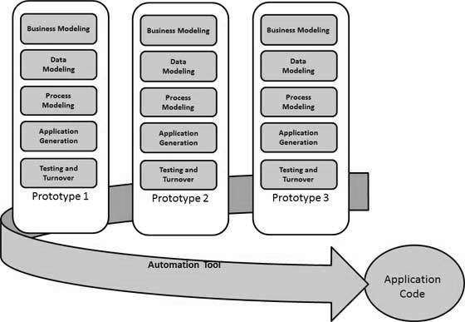

When to use RAD Methodology?
- When a system needs to be produced in a short span of time (2-3 months)
- When the requirements are known
- When the user will be involved all through the life cycle
- When technical risk is less
- When there is a necessity to create a system that can be modularized in 2-3 months of time
- When a budget is high enough to afford designers for modeling along with the cost of automated tools for code generation

Advantage of RAD Model
- This model is flexible for change.
- In this model, changes are adoptable.
- Each phase in RAD brings highest priority functionality to the customer.
- It reduced development time.
- It increases the reusability of features.

Disadvantage of RAD Model
- It required highly skilled designers.
- All application is not compatible with RAD.
- For smaller projects, we cannot use the RAD model.
- On the high technical risk, it's not suitable.
- Required user involvement.

Advantages of RAD Model | Disadvantages of RAD Model
- Flexible and adaptable to changes | - It can't be used for smaller projects
- It is useful when you have to reduce the overall project risk | - Not all application is compatible with RAD
- It is adaptable and flexible to changes | - When technical risk is high, it is not suitable
- It is easier to transfer deliverables as scripts, high-level abstractions and intermediate codes are used | - If developers are not committed to delivering software on time, RAD projects can fail
- Due to code generators and code reuse, there is a reduction of manual coding | - Reduced features due to time boxing, where features are pushed to a later version to finish a release in short period
- Due to prototyping in nature, there is a possibility of lesser defects | - Reduced scalability occurs because a RAD developed application begins as a prototype and evolves into a finished application
- Each phase in RAD delivers highest priority functionality to client | - Progress and problems accustomed are hard to track as such there is no documentation to demonstrate what has been done
- With less people, productivity can be increased in short time | - Requires highly skilled designers or developers

- 1.1.2.5 Rational Unified Process (RUP) :-
The Rational Unified Process (RUP) is an iterative software development process framework created by the Rational Software Corporation, a division of IBM since 2003. RUP is not a single concrete prescriptive process, but rather an adaptable process framework, intended to be tailored by the development organizations and software project teams that will select the elements of the process that are appropriate for their needs. RUP is a specific implementation of the Unified Process.

Rational Software originally developed the rational unified process as a software process product.

RUP building blocks :-

RUP is based on a set of building blocks and content elements, describing what is to be produced, the necessary skills required and the step-by-step explanation describing how specific development goals are to be achieved. The main building blocks, or content elements, are the following:
- Roles (who) – A role defines a set of related skills, competencies and responsibilities.
- Work products (what) – A work product represents something resulting from a task, including all the documents and models produced while working through the process.
- Tasks (how) – A task describes a unit of work assigned to a Role that provides a meaningful result.
Within each iteration, the tasks are categorized into nine disciplines:

- Six "engineering disciplines"
  - Business modeling
  - Requirements
  - Analysis and design
  - Implementation
  - Test
  - Deployment

- Three supporting disciplines
  - Configuration and change management
  - Project management
  - Environment

Four project life-cycle phases :-

The RUP has determined a project life-cycle consisting of four phases. These phases allow the process to be presented at a high level in a similar way to how a 'waterfall'-styled project might be presented, although in essence the key to the process lies in the iterations of development that lie within all of the phases. Also, each phase has one key objective and milestone at the end that denotes the objective being accomplished. The visualization of RUP phases and disciplines over time is referred to as the RUP hump chart.

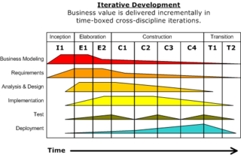

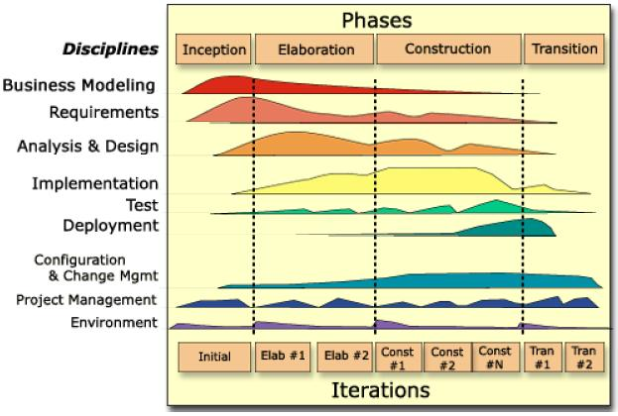

- Inception phase :-

The primary objective is to scope the system adequately as a basis for validating initial costing and budgets. In this phase the business case which includes business context, success factors (expected revenue, market recognition, etc.), and financial forecast is established. To complement the business case, a basic use case model, project plan, initial risk assessment and project description (the core project requirements, constraints and key features) are generated. After these are completed, the project is checked against the following criteria:
- Stakeholder concurrence on scope definition and cost/schedule estimates.
- Requirements understanding as evidenced by the fidelity of the primary use cases.
- Credibility of the cost/schedule estimates, priorities, risks, and development process.
- Depth and breadth of any architectural prototype that was developed.
- Establishing a baseline by which to compare actual expenditures versus planned expenditures.

The idea for the project is stated. The development team determines if the project is worth pursuing and what resources will be needed.

- Communication and planning are main.

- Identifies Scope of the project using use-case model allowing managers to estimate costs and time required.

- Customers requirements are identified and then it becomes easy to make a plan of the project.

- Project plan, Project goal, risks, use-case model, Project description, are made.

- Project is checked against the milestone criteria and if it couldn’t pass these criteria then project can be either cancelled or redesigned.

If the project does not pass this milestone, called the life cycle objective milestone, it either can be cancelled or repeated after being redesigned to better meet the criteria.

- Elaboration phase :-
The primary objective is to mitigate the key risk items identified by analysis up to the end of this phase. The elaboration phase is where the project starts to take shape. In this phase the problem domain analysis is made and the architecture of the project gets its basic form.
The outcome of the elaboration phase is:
- A use-case model in which the use-cases and the actors have been identified and most of the use-case descriptions are developed. The use-case model should be 80% complete.
- A description of the software architecture in a software system development process.
- An executable architecture that realizes architecturally significant use cases.
- Business case and risk list which are revised.
- A development plan for the overall project.
- Prototypes that demonstrably mitigate each identified technical risk.
- A preliminary user manual (optional)
This phase must pass the lifecycle architecture milestone criteria answering the following questions:
- Is the vision of the product stable?
- Is the architecture stable?
- Does the executable demonstration indicate that major risk elements are addressed and resolved?
- Is the construction phase plan sufficiently detailed and accurate?
- Do all stakeholders agree that the current vision can be achieved using current plan in the context of the current architecture?
- Is the actual vs. planned resource expenditure acceptable?

The project's architecture and required resources are further evaluated. Developers consider possible applications of the software and costs associated with the development

  - Planning and modeling are main.
  - Detailed evaluation, development plan is carried out and diminish the risks.
  - Revise or redefine use-case model (approx. 80%), business case, risks.
  - Again, checked against milestone criteria and if it couldn’t pass these criteria then again project can be cancelled or redesigned.
  - Executable architecture baseline.

If the project cannot pass this milestone, there is still time for it to be canceled or redesigned. However, after leaving this phase, the project transitions into a high-risk operation where changes are much more difficult and detrimental when made.

The key domain analysis for the elaboration is the system architecture.

- Construction phase :-

The primary objective is to build the software system. In this phase, the main focus is on the development of components and other features of the system. This is the phase when the bulk of the coding takes place. In larger projects, several construction iterations may be developed in an effort to divide the use cases into manageable segments to produce demonstrable prototypes.

The project is developed and completed. The software is designed, written, and tested.

  - Project is developed and completed.
  - System or source code is created and then testing is done.
  - Coding takes place.

- Transition phase :-

The primary objective is to 'transit' the system from development into production, making it available to and understood by the end user. The activities of this phase include training the end users and maintainers and beta testing the system to validate it against the end users' expectations. The system also goes through an evaluation phase, any developer which is not producing the required work is replaced or removed. The product is also checked against the quality level set in the Inception phase.
If all objectives are met, the product release milestone is reached and the development cycle is finished.

The software is released to the public. Final adjustments or updates are made based on feedback from end users.

  - Final project is released to public.
  - Transit the project from development into production.
  - Update project documentation.
  - Beta testing is conducted.
  - Defects are removed from project based on feedback from public.
  - Project is maintained and updated accordingly

The RUP development methodology provides a structured way for companies to envision create software programs. Since it provides a specific plan for each step of the development process, it helps prevent resources from being wasted and reduces unexpected development costs.

